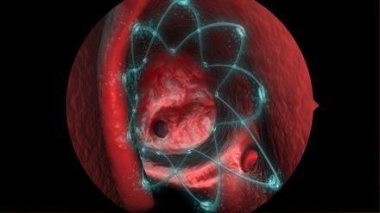

**CHRONIC SINUSITIS SYMPTOMS**

*Images courtesy of Intersect® ENT*

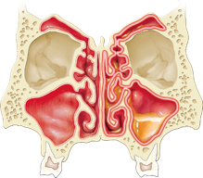

**Healthy**

**Normal**

**Sinus**

**Diseased**

**Inflamed**

**Sinus**

Facial pain/pressure

Congestion

Headache

Nasal discharge

Loss of smell or taste



Sinusitis is among the most common diagnoses for those who visit their physician complaining of coughing, sinus pressure, congestion, postnasal drainage and headaches. One in eight adults suffers from sinusitis today1. Often, patients misdiagnose themselves as simply suffering from seasonal allergies or a persistent cold. While medications such as nasal sprays, antibiotics and antihistamines can provide temporary relief, many times they do not solve the problem and a surgical procedure may be required.

**A new treatment for sinus sufferers:**

Dr. Marc Kerner is now placing the dissolvable PROPEL Sinus Stent at the end of surgery. The lightweight stent helps keep the sinus cavities openafter surgery and steadily delivers local anti-inflammatory medication to the healing sinus tissue.

The PROPEL Stent improves patient outcomes and the healing process2, plus patients hardly know it is there.

**How it works:**

The PROPEL Stent is carefully inserted by an experienced Ear, Nose and Throat physician into the sinus cavity at the end of surgery. The stent remains there for a few weeks, utilizing a spring-like mechanism to open up the nasal passageway. At the same time, it provides anti-inflammatory therapy to enhance healing. The stent slowly dissolves on its own, and no removal is necessary, making postoperative care easier on patients.

**Clinical Data:**

PROPEL has been studied in three prospective, randomized clinical trials conducted in the United States demonstrating reduced scarring and reduced need for oral steroids2.

**Conclusion:**

When a patient's chronic sinusitis does not respond to medications, surgery to enlarge the opening to drain the sinuses may provide the best option. The PROPEL Sinus Stent offers a new weapon in the fight against chronic sinusitis, backed by clinical data and positive outcomes.

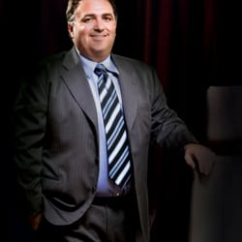

Dr. Marc Kerner  
18350 Roscoe Blvd, Suite 318

Northridge, CA 91325

P (818) 349-0600

www.calwestent.com

Learn more about the PROPEL® Sinus Stent

**PROPEL Sinus Stent**

Chronic Sinus Sufferers   
Have a New Weapon

**Dr. Marc Kerner**

**Call now to find out more.**

**818-349-0600**

MPM 00183 Rev. B